MONTGOMERY COLLEGE, ROCKVILLE

Physics, Engineering and Geosciences Department

EE 244 – Digital Logic Design

Spring 2009

Final Practice

- (5) convert the following decimal number to hexadecimal: 227.
Your answer: ____________________________

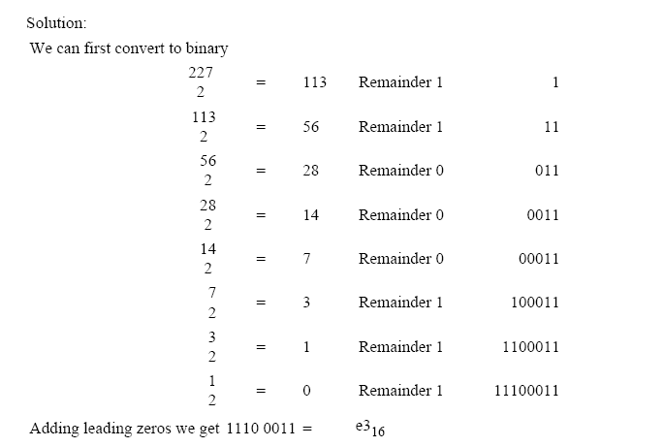

- (10) Design a circuit to multiply two 2-bit numbers -a,b and c,d and produce a 4-bit product – w, x, y, z. show a truth table and minimum SOP expressions.

b_{in} | x | y | b_{out} | d
0 | 0 | 0 | 0 | 0
0 | 0 | 1 | 1 | 1
0 | 1 | 0 | 0 | 1
0 | 1 | 1 | 0 | 0
1 | 0 | 0 | 1 | 1
1 | 0 | 1 | 1 | 0
1 | 1 | 0 | 0 | 0
1 | 1 | 1 | 1 | 1

- (15) For the following state table, complete the timing trace as far as possible (even after the input in no longer known).

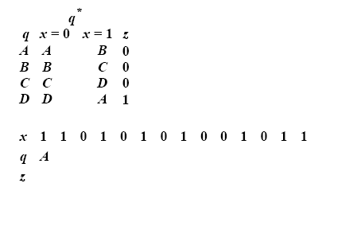

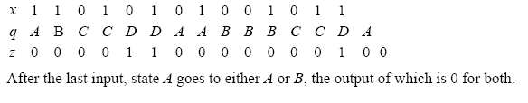
- (35) For the following circuit, complete the timing trace as far as possible. The state of some flip flops and the output can be determined for as many as three clocks after the input is no longer known. Assume that all flip flops are initially 0. Also show state table and state diagram.

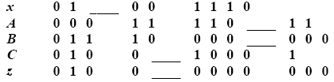
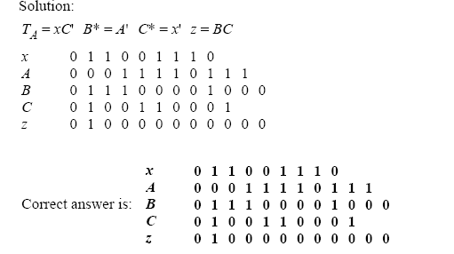

- (35) Design a counter with two JK flip flops, A and B, and one input x. If x = 0, it counts 1,3,0, and repeat; if x = 1, it counts 1, 2, 3 and repeat.
